|  |
| --- |
| Circle Language Spec: System Objects |

## System Aspects

The behavior of objects, references and lists is controlled by controlling their *aspects*. This article lists out the various aspects of objects, references and lists. The pictures show the aspects’ main diagram symbolization.

Object

The Object aspect determines which object is pointed to.

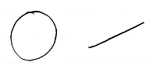

Class

The Class aspect determines which other object will function as the prototype of another object. It can also bind a reference to a class.



Interface

The Interface aspect allows you to control how objects look on the outside, while the insides of the objects can differ completely. The Interface aspect is separately covered in the *Interfaces* article group, and will not be mentioned in the *System Aspects* article group any further.

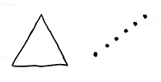

Value

The Value aspect allows you to store binary content and allows you to yield over values from one object to another.

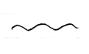

Execute

The Execute aspect is about being able to execute an object as a command.

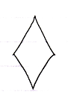

List

The List aspect allows you to add and removeitems from a list.



Name

The Name aspect allows you to give names to objects, lists and references.

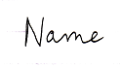

Existence

The existence aspect allows you to create a new object. You can also annul an object reference to make it point to nothing. You can also *check* whether an object reference is Nothing.



(This is the main symbolization of Nothing.)

Data

With the data aspect you can control whether you have reading or writing access. Instead of being able to access-control the direct object, the Data aspect controls read-write access to all of the sub-objects as well.



Clone

The Clone aspect is related to the Value aspect, but will also copy values of sub-objects.

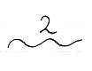

Reference

Sometimes no aspect of a reference is called upon, but there is worked directly with the reference itself. That is not really an aspect, but in that case it is said you are calling upon the Reference aspect.



Here is the list of aspects again:

Object

Class

Interface

Value

Execute

List

Name

Existance

Data

Clone

Reference